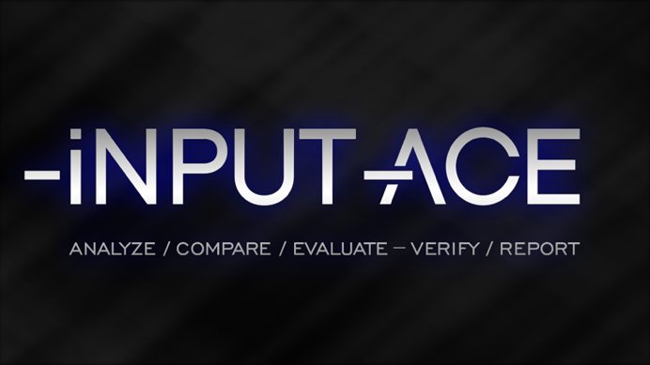

*About iNPUT-ACE:*

*The iNPUT-ACE software is a powerful multimedia workflow engine for police investigators that helps streamline the analysis and processing of video evidence for legal matters.*

*"I am very happy with the quality of work and professionalism that Kevin and the rest of the IntelliTect team have brought to the iNPUT-ACE project. Their work ethic, creativeness, and overall broad skill-sets pushed our software to the next level.”*

*- Andrew Fredericks*

*iNPUT-ACE Project Manager*

## Problem

Occam Video Solutions is a well-known and respected digital video analysis company. They set out to create a program that would speed up and automate the time-consuming operation of video processing to extract specific information from video evidence. Occam Video Solutions had developed a prototype software, but they wanted to build a more intuitive and powerful custom solution because existing video processing solutions are not tailored to forensic video analysis.

## Solution

IntelliTect worked closely with Occam Video Solutions and began to build iNPUT-ACE, an advanced video editing software program with the ability to interact with proprietary video files immediately—without transcoding. Some of the features of the program include a drag and drop interface, extracting sub-clips or frames, built-in player functionality, and the ability to move forward and backward through the frames and tools for interpreting video compression. All these features work immediately, without waiting for large proprietary files to process.

## Results

IntelliTect has managed the lifecycle of the application since May 2015 and has assisted in releasing over two dozen updated versions of the software according to Occam Video Solutions specifications. Recently, Occam Video Solutions asked IntelliTect to locate an in-house developer for their company. IntelliTect is bringing that developer up to speed on the project and will continue to assist with the program as needed.

According to iNPUT-ACE.com, “this powerful workflow engine has set new standards for the examination, processing, and presentation of video in criminal investigations.” The software was initially written to improve the workflow of Occam Video Solution’s staff, but it quickly gained recognition as the most powerful digital video processing engine available to law enforcement. Now, iNPUT-ACE and its software support is in use by police agencies throughout North America, South America and in Europe.

IntelliTect provides high-end architecture consulting, full life-cycle software development, and training that enables our clients to solve their most challenging problems. Our expert principal and senior engineers specialize in the latest technologies, including Cloud Computing (both [AWS](https://aws.amazon.com/) and [Azure](https://azure.microsoft.com/en-us/)), Big Data, Machine Learning, and Artificial Intelligence (AI), [.NET Development](https://dotnet.microsoft.com/en-us/), [Azure DevOps](https://azure.microsoft.com/en-us/services/devops/), [Office365](https://www.microsoft.com/en-us/microsoft-365)/SharePoint, and Enterprise Application Integration. For more info, go to intellitect.com.

IntelliTect provides excellence in Microsoft development technologies through coding, training and consultation with special expertise in SharePoint, BizTalk, WPF, WCF, multithreading and Visual Studio Team System ALM.